

PROJECT 13

Injection-Molded Plastic Parts Defect Detection

Final Group Project Report

ENEL4AIH2 – Artificial Intelligence

GROUP 8

Name | Student No. | Project Responsibility
Siduduzo Shandu | 223004057 | Dataset Preparation and Data Engineering
Abongile Nzama | 223036784 | EfficientNet Model Development and Training
Aphiwe Sithole | 223012528 | Evaluation, Baseline and Interpretability
Muzikayise Ndlovu | 223043048 | Flask Prototype, API, Deployment and Documentation

Submission Date: 19 September 2026

Table of Contents

1. Introduction and Project Scope 4
1.1. Background 4
1.2. Project Objective 4
1.3. Deliverables and Scope 4
1.4. Main Contribution 4
1.5. Team Work Allocation 4
1.5.1. Dataset Preparation and Data Engineering 4
1.5.2. EfficientNet Model Development and Training 4
1.5.3. Evaluation, Baseline and Interpretability 4
1.5.4. Flask Prototype, API, Deployment and Documentation 5
2. Dataset Preparation and Leakage Control 6
2.1. Dataset Expansion 6
2.2. Leakage-Resistant Splitting 6
2.3. Preprocessing and Augmentation 6
3. Model Architecture and System Methodology 7
3.1. EfficientNet-B0 Transfer Learning 7
3.2. Multi-Label Formulation 7
3.3. Architecture Flow 7
3.4. ResNet18 Baseline 7
4. Training Strategy and Threshold Selection 8
4.1. Two-Phase Training 8
4.2. Model Selection 8
4.3. Validation-Based Threshold Selection 8
5. Final Model Evaluation 9
5.1. Held-Out Test Performance 9
5.2. Error Characteristics 9
5.3. Interpretation of the Final Metrics 9
6. Generalization and Baseline Comparison 10
6.1. Why a Strict Comparison Was Needed 10
6.2. Result of Dataset Expansion 10
6.3. Baseline Interpretation 10
7. Working Prototype, Flask API and Imaging Setup 11
7.1. Flask Web Prototype 11
7.2. Grad-CAM Interpretability 11
7.3. Flask API and Phone Integration 11
8. Limitations, Social, Ethical and Environmental Considerations 12
8.1. Technical Limitations 12
8.2. Health, Safety and Public Interest 12
8.3. Ethical Considerations 12
8.4. Environmental Considerations 12
8.5. Consistent Imaging 12
9. Conclusion and Recommendations 13
9.1. Conclusion 13
9.2. Recommendations for Future Work 13
References 14
Submission Notes 15

List of Figures
Figure 1. EfficientNet-B0 V2 per-class confusion matrices ....................................... 7
Figure 2. Final prototype prediction and Grad-CAM output ........................................ 9
Figure 3. End-to-end deployment workflow ................................................................ 9

List of Tables
Table 1. Final dataset split and class occurrence distribution ................................... 4
Table 2. Final model training configuration ................................................................ 6
Table 3. Final EfficientNet-B0 test performance ....................................................... 7
Table 4. Strict original-model versus V2 comparison ................................................ 8

1. Introduction and Project Scope

1.1. Background
Injection molding is widely used for high-volume production of plastic components, but visible manufacturing defects can reduce appearance quality, assembly accuracy, and functional reliability. Manual visual inspection is labor-intensive and may be inconsistent when defect appearance varies or when production volumes are high. Deep convolutional neural networks provide a practical route to automated image-based inspection, particularly when transfer learning is used to compensate for limited industrial training data[1]. Similarly, it was demonstrated that transfer learning and augmentation can improve injection-molding defect inspection when labeled samples are scarce.

1.2. Project Objective
The objective of this project was to develop a working prototype that identifies visually distinct injection-molded plastic defects from an input image. In accordance with the recommended four-week project scope, the system was limited to four defect classes: Burn Mark, Flash, Short Shot, and Sink Mark. Warping was not included because the brief explicitly recommended limiting implementation to three or four visually distinct defect classes. The final system performs multi-label classification, which allows more than one defect to be reported for the same image.

1.3. Deliverables and Scope
The completed deliverables comprise a Python/PyTorch classification pipeline, an EfficientNet-B0 transfer-learning model, a ResNet18 baseline experiment, leakage-resistant dataset construction, validation-based threshold optimisation, a Flask web prototype, a JSON prediction API, direct phone-camera capture, upload of existing images, and Grad-CAM-based approximate localization. A physical light-box concept is used for consistent image acquisition by controlling illumination, background, camera distance, and viewing angle. The system is a prototype for screening and demonstration rather than a certified industrial quality-control instrument.

1.4. Main Contribution
The principal technical contribution is an end-to-end defect-screening workflow that combines a compact transfer-learning architecture with explicit controls against train-test image leakage. The project also evaluates whether increasing the dataset size and diversity improves generalization. This was tested by comparing the original model and the final V2 model on a strict subset containing no exact or strong perceptual match to any image in the original 262-image corpus.

1.5. Team Work Allocation

1.5.1. Dataset Preparation and Data Engineering
Siduduzo Shandu (223004057) was responsible for dataset inspection, four-class selection, duplicate and near-duplicate analysis, group-aware splitting, CSV generation, preprocessing, and augmentation.

1.5.2. EfficientNet Model Development and Training
Abongile Nzama (223036784) was responsible for EfficientNet-B0 transfer learning, class-weighted BCE loss, two-phase training, checkpoint selection, threshold optimization, and final model configuration.

1.5.3. Evaluation, Baseline, and Interpretability
Aphiwe Sithole (223012528) was responsible for final test evaluation, confusion matrix analysis, the ResNet18 baseline, a strict original model versus V2 comparison, and Grad-CAM interpretability.

1.5.4. Flask Prototype, API, Deployment, and Documentation
Muzikayise Ndlovu (223043048) was responsible for the Flask interface, phone-camera/gallery input, REST API, single-action workflow, Render deployment, GitHub/README integration, and final documentation.

2. Dataset Preparation and Leakage Control

2.1. Dataset Expansion
The first model was developed from a 262-image dataset. A larger plastic-defect dataset was then inspected and adopted as the final source because it contained all original images together with additional plastic-part images. The final source contains 975 images. The four selected target classes occur 364 times for Burn Mark, 380 times for Flash, 150 times for Short Shot, and 323 times for Sink Mark. Since the task is multi-label, class occurrence totals can exceed the number of images. Images containing other non-selected defect labels were retained as negatives with respect to the four target classes; they are therefore not described as universally defect-free.
Split | Images | Burn Mark | Flash | Short Shot | Sink Mark
Training | 683 | 257 | 266 | 111 | 227
Validation | 146 | 49 | 61 | 19 | 47
Test | 146 | 58 | 53 | 20 | 49
Total | 975 | 364 | 380 | 150 | 323
Table 1. Final dataset split and target-class occurrence distribution.

2.2. Leakage-Resistant Splitting
A key concern was that visually near-identical images could be distributed across training and test partitions. To reduce this risk, the original split was discarded and replaced with a custom group-aware split. SHA-256 was used for exact duplicates, while perceptual hash, difference hash, and cosine similarity of normalized grayscale image vectors were used to identify strong visual similarity. Horizontal-flip variants were also checked. Two images were treated as a strong near-duplicate pair when the pHash distance was at most 4, the dHash distance was at most 6, and the cosine similarity was at least 0.985. Similar images were grouped before the train, validation, and test partitions were assigned.
The 975 images formed 708 similarity groups. Fifty-two groups contained multiple images, 319 images belonged to multi-image groups, and the largest group contained 97 images. Every similarity group was constrained to a single split. This procedure does not prove complete semantic independence, because perceptual thresholds are heuristic, but it materially reduces a common source of optimistic evaluation in visually repetitive datasets.

2.3. Preprocessing and Augmentation
Images are resized to 224 × 224 pixels and normalized with the ImageNet mean [0.485, 0.456, 0.406] and standard deviation [0.229, 0.224, 0.225]. Training augmentation consists of random horizontal flips, rotations of up to ±10 degrees, and mild variations in brightness and contrast. Validation and test images are only resized and normalized. These transformations preserve the defect semantics while introducing limited appearance variation, which can reduce overfitting; augmentation is a standard strategy for improving generalization in data-limited deep learning settings [6].

3. Model Architecture and System Methodology

3.1. EfficientNet-B0 Transfer Learning
EfficientNet-B0 was selected as the final classifier because it provides a favourable accuracy-to-computation trade-off. EfficientNet scales depth, width and resolution in a coordinated manner [2], which makes the B0 variant practical for CPU-based development and deployment. The network was initialized with ImageNet-pretrained weights. ImageNet provides broad visual feature representations that are useful when adapting a model to smaller domain-specific datasets [5]. The original EfficientNet classifier was replaced with a four-output linear layer, one logit for each defect class.

3.2. Multi-Label Formulation
The four output logits are converted to independent probabilities using the sigmoid function. This differs from softmax classification because the four classes are not mutually exclusive. The loss function is BCEWithLogitsLoss, which combines the sigmoid operation with binary cross-entropy in a numerically stable implementation. Positive class weights were used to mitigate class imbalance. The final training weights were approximately 1.6576 for Burn Mark, 1.5677 for Flash, 5.1532 for Short Shot, and 2.0088 for Sink Mark. The much larger Short Shot weight reflects its lower positive frequency in the training split.

3.3. Architecture Flow
Stage | Operation | Output
1 | Image acquisition | Phone camera or uploaded JPG/PNG
2 | Preprocessing | 224 × 224 normalized tensor
3 | EfficientNet-B0 | Four defect logits
4 | Sigmoid | Four independent probabilities
5 | Threshold = 0.40 | Detected / Clear decision per class
6 | Grad-CAM when detected | Approximate influential region
7 | Flask interface / API | Human-readable UI or JSON response
System processing stages from image acquisition to prediction output.

3.4. ResNet18 Baseline
A ResNet18 model was implemented as a baseline architecture. ResNet uses residual connections to make deeper networks easier to optimize [3]. The baseline used the same four-class multi-label formulation and a two-phase transfer-learning procedure. Its purpose was not to replace the final system, but to provide evidence that architecture and training choices were compared rather than selected without evaluation.

4. Training Strategy and Threshold Selection

4.1. Two-Phase Training
Training was performed in two stages. During the first five epochs, the pretrained feature extractor was frozen, and only the classifier head was optimized with Adam at a learning rate of 1×10^-3. The complete network was then unfrozen and fine-tuned for 10 epochs using Adam with a learning rate of 1×10^-4. The batch size was 16. This strategy first adapts the new classifier to the defect labels, then allows lower- and higher-level visual features to adjust to the injection-molded plastic domain.
Parameter | Final Value
Architecture | EfficientNet-B0
Pretraining | ImageNet
Input resolution | 224 × 224
Batch size | 16
Head-only training | 5 epochs, Adam, learning rate 1×10^-3
Full fine-tuning | 10 epochs, Adam, learning rate 1×10^-4
Loss | Weighted BCEWithLogitsLoss
Checkpoint criterion | Lowest validation loss
Best validation loss | 0.6494
Table 2. Final EfficientNet-B0 V2 training configuration.

4.2. Model Selection
The best V2 checkpoint occurred at fine-tuning epoch 6, where validation loss reached 0.6494. Training loss continued to fall afterward while validation loss did not improve consistently, indicating the onset of mild overfitting. Selecting the lowest-validation-loss checkpoint, therefore, prevented the final deployment model from simply using the last training epoch.

4.3. Validation-Based Threshold Selection
The default threshold of 0.50 was not assumed to be optimal. A global threshold search from 0.10 to 0.90 in increments of 0.05 was performed using only the 146-image validation set. Macro F1-score was the selection criterion because it gives equal importance to each defect class. The best validation Macro F1 was 0.6459 at a threshold of 0.40; this value was then locked before final test evaluation. At 0.40, validation Macro Recall was 0.8340 and Micro F1 was 0.6667. No test-set results were used to adjust the threshold.

5. Final Model Evaluation

5.1. Held-Out Test Performance
The final EfficientNet-B0 V2 checkpoint was evaluated once on the complete 146-image held-out test split using the locked 0.40 threshold. The model achieved Macro Precision of 0.5328, Macro Recall of 0.8537, and Macro F1 of 0.6292. Micro Precision was 0.5190, Micro Recall was 0.8333, and Micro F1 was 0.6397. Exact-match accuracy was 23.97%, while Hamming accuracy was 71.06%. Exact-match is intentionally strict in a multi-label problem because every class decision for an image must be correct for the sample to count as an exact match.
Class | Precision | Recall | F1 | Support
Burn Mark | 0.6471 | 0.7586 | 0.6984 | 58
Flash | 0.7500 | 0.8491 | 0.7965 | 53
Short Shot | 0.2676 | 0.9500 | 0.4176 | 20
Sink Mark | 0.4667 | 0.8571 | 0.6043 | 49
Macro average | 0.5328 | 0.8537 | 0.6292 | —
Micro average | 0.5190 | 0.8333 | 0.6397 | 180 positive labels
Table 3. Final EfficientNet-B0 V2 results on the 146-image held-out test set.
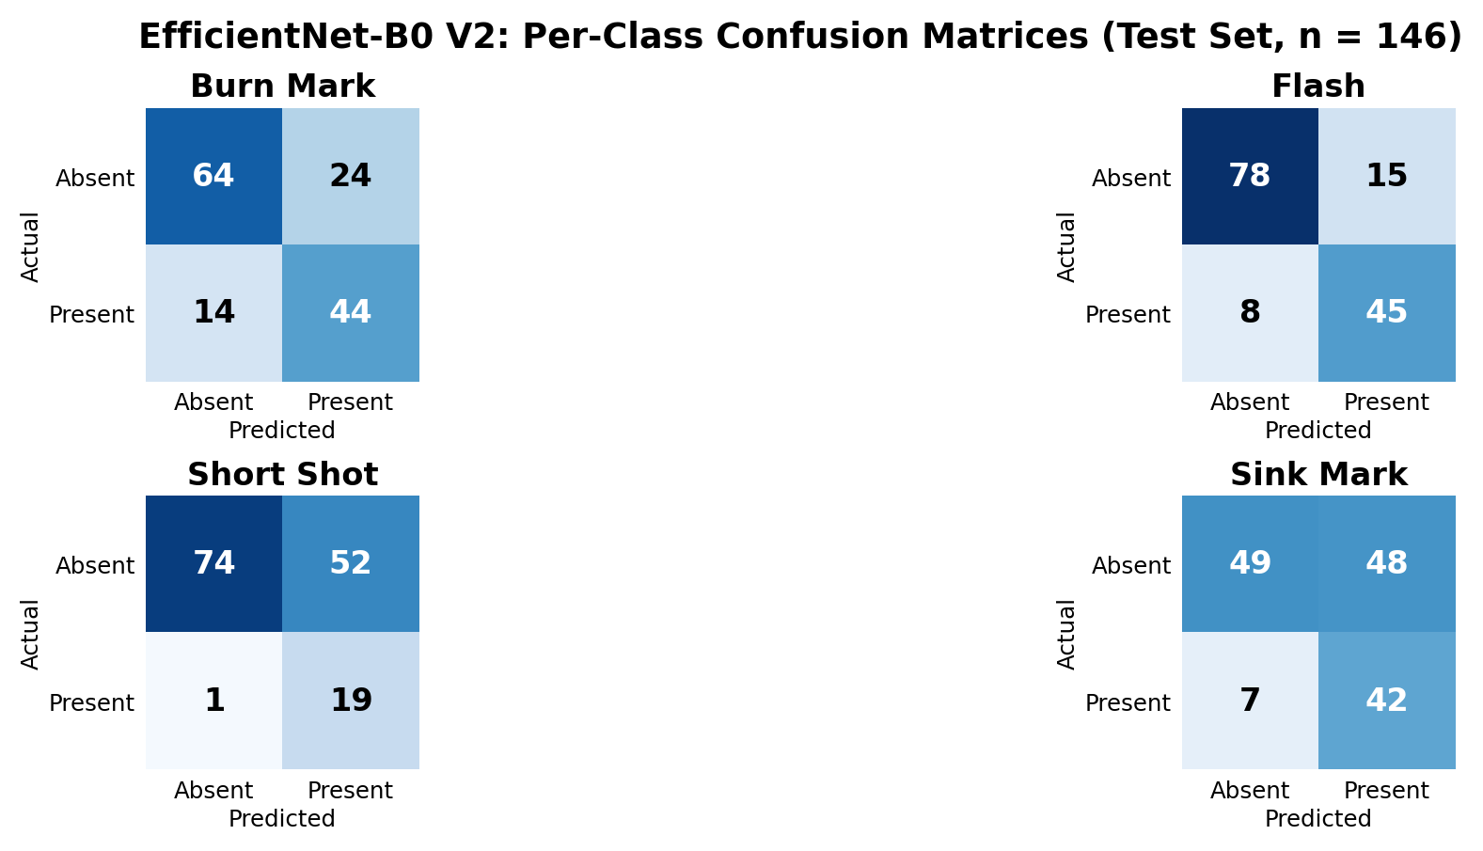
Figure 1. Per-class confusion matrices for EfficientNet-B0 V2 on the 146-image held-out test set at the locked 0.40 threshold.

5.2. Error Characteristics
Figure 1 shows the binary error pattern for each defect class: Flash has the strongest balance of true positives and false positives, while Short Shot and Sink Mark generate the largest numbers of false positives. Flash was the strongest class by F1-score at 0.7965, followed by Burn Mark at 0.6984. Sink Mark achieved high recall but moderate precision. Short Shot had the highest recall (0.9500) but the lowest precision (0.2676). Its confusion counts were 19 true positives, 1 false negative, and 52 false positives. This means the final system is deliberately sensitive to Short Shot and may raise unnecessary alarms. For screening, high recall can be useful because missed defects may be costly, but low precision must be clearly stated and improved before industrial deployment.

5.3. Interpretation of the Final Metrics
The final results show that the system is better suited to defect screening than to autonomous acceptance or rejection of production parts. The high Macro Recall of 0.8537 indicates that most positive cases across the four classes were detected, while the lower precision indicates that some detections require human confirmation. This trade-off is acceptable for a prototype whose role is to assist visual inspection rather than replace a quality engineer without supervision.

6. Generalization and Baseline Comparison

6.1. Why a Strict Comparison Was Needed
The 975-image source dataset includes all 262 images from the original dataset. Therefore, directly comparing the old model and V2 on the complete final test set could give the old model an unfair advantage on images it had previously encountered. To make the dataset-expansion experiment more defensible, every final-test image that was an exact or strong perceptual near-duplicate of any image in the entire original 262-image corpus was removed. The same strict perceptual criteria used during dataset construction were applied. This left 91 images that were outside the original corpus under the selected matching rules.
Metric | Original Model | V2 Model | Change
Macro Precision | 0.4447 | 0.5501 | +0.1053
Macro Recall | 0.3512 | 0.8833 | +0.5321
Macro F1 | 0.3779 | 0.6645 | +0.2867
Micro Precision | 0.5714 | 0.5693 | -0.0021
Micro Recall | 0.4275 | 0.8779 | +0.4504
Micro F1 | 0.4891 | 0.6907 | +0.2016
Exact Match | 0.1538 | 0.2747 | +0.1209
Hamming Accuracy | 0.6786 | 0.7170 | +0.0385
Table 4. Strict comparison on 91 images with no exact or strong perceptual match to the original 262-image corpus.

6.2. Result of Dataset Expansion
The strict comparison provides the strongest evidence that the larger training corpus improved generalization. V2 increased Macro F1 from 0.3779 to 0.6645 and Micro F1 from 0.4891 to 0.6907. Macro Recall increased from 0.3512 to 0.8833. The original model detected none of the 12 Short Shot positives in this strict subset, whereas V2 achieved Short Shot recall of 0.9167 and F1 of 0.4889. Micro Precision remained almost unchanged, decreasing by only 0.0021, while recall and F1 improved substantially.

6.3. Baseline Interpretation
The earlier ResNet18 baseline on the initial dataset achieved Macro F1 of 0.47 and Micro F1 of 0.49 at its validation-selected threshold. That result supported the initial choice of EfficientNet-B0, but it is not presented as a fully controlled final-architecture comparison because the baseline was not retrained on the 975-image leakage-resistant split. For that reason, the report gives the greatest weight to the final EfficientNet test metrics and the strict old-versus-V2 EfficientNet comparison.

7. Working Prototype, Flask API, and Imaging Setup

7.1. Flask Web Prototype
The final EfficientNet-B0 model is integrated into a Flask application called PlasticVision AI. Users can either capture a new image with a compatible phone rear camera or select an existing JPG/PNG file, then press the Analyze Image button. The interface reports all four probabilities, Detected/Clear decisions at the 0.40 threshold, and an overall defect status.
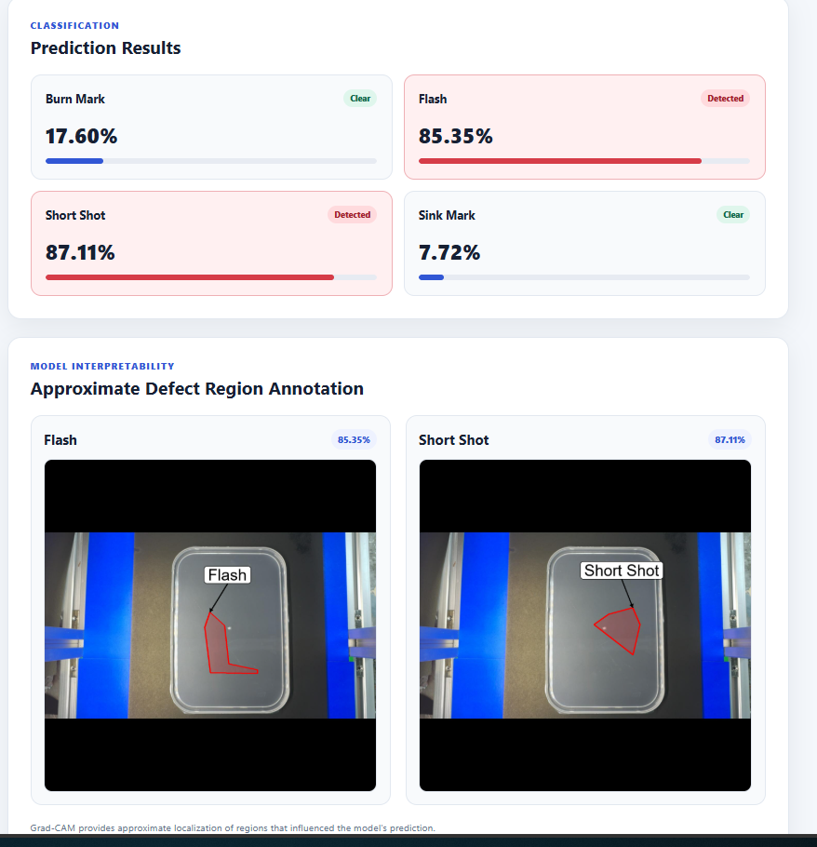
Figure 2. Final prototype output showing multi-label probabilities and class-specific Grad-CAM annotations.

7.2. Grad-CAM Interpretability
Grad-CAM uses gradients flowing into a convolutional feature layer to create a coarse class-discriminative localization map [4]. Localization is generated only for detected classes, with a contour and label overlaid on an influential region. It is explicitly presented as approximate because Grad-CAM is not a segmentation algorithm and does not define a ground-truth defect boundary.

7.3. Flask API and Phone Integration
The application also exposes the POST /api/predict endpoint, which accepts an image and returns JSON with probabilities, detected classes, and the threshold. API calls omit Grad-CAM for faster inference. Flask binds to 0.0.0.0:5000, allowing a phone on the same local network to access the laptop server via IPv4 and serve as the image-acquisition device without a separate Android application.
Light box | Phone camera | Flask server | EfficientNet-B0 V2 | Results
Controlled lighting/background | Rear-camera capture | Web UI or POST /api/predict | 4 sigmoid probabilities, threshold 0.40 | Detected/Clear + optional Grad-CAM
Figure 3. End-to-end deployment workflow for consistent image capture and prediction.

8. Limitations, Social, Ethical, and Environmental Considerations

8.1. Technical Limitations
The dataset remains modest in size compared with mature industrial inspection datasets, and several images originate from related manufacturing contexts. Similarity-aware splitting reduces but cannot eliminate every form of domain dependence. The largest model weakness is Short Shot precision, which creates a relatively high false-positive rate. The model also predicts image-level labels rather than pixel-level masks. Grad-CAM should therefore be treated as an explanation aid, not as measured defect geometry. Before deployment on a production line, the model should be tested on images acquired from the actual target plant, camera, material, molds, and lighting conditions.

8.2. Health, Safety, and Public Interest
Automated visual screening can support health and safety by identifying suspect components before they reach later assembly or users. However, an incorrect prediction can also create risk if a defective part is accepted solely because the model returned a low probability. The prototype should therefore operate as a decision-support tool with human review, especially for safety-critical components. The interface exposes probabilities rather than a binary label, making uncertainty visible, and the report documents class-specific weaknesses rather than presenting the model as universally reliable.

8.3. Ethical Considerations
The principal ethical concerns are transparency, accountability, and appropriate reliance on automated decisions. Grad-CAM was included to provide limited interpretability, but its visualization must not be represented as proof of causality or exact defect localization. Dataset provenance and usage rights should be recorded in the repository, and any future collection of production images should avoid including personal or confidential information. Human inspectors should retain authority to override predictions, and model performance should be periodically reviewed for drift when new products or manufacturing conditions are introduced.

8.4. Environmental Considerations
Defect detection has two opposing environmental effects. Earlier detection can reduce downstream processing of unusable parts, rework, transport, and assembly waste. Conversely, overly sensitive classification can lead to unnecessary rejections and plastic waste. The model should therefore be calibrated against the cost of false negatives and false positives in the intended production setting. EfficientNet-B0 was also a reasonable architecture choice for a student prototype because its compact design reduces training and inference demand relative to much larger vision networks.

8.5. Consistent Imaging
The suggested light-box and phone-camera arrangement addresses an important source of deployment variability. A simple diffuse light box with a fixed phone position and consistent background can reduce shadows, reflections, color shifts, and scale changes. The imaging enclosure does not require electronic integration with the model; its purpose is repeatability. During future data collection, the same setup should be used for training and operational images so that the model learns defect appearance rather than incidental lighting differences.

9. Conclusion and Recommendations

9.1. Conclusion
This project delivered a complete prototype for multi-label visual inspection of injection-molded plastic parts. The final system detects Burn Mark, Flash, Short Shot, and Sink Mark using an ImageNet-pretrained EfficientNet-B0 model implemented in PyTorch. A leakage-resistant 683/146/146 train-validation-test split was built from a 975-image source dataset. Class imbalance was handled through weighted binary cross-entropy, the model was trained using a two-stage transfer-learning procedure, and the global decision threshold of 0.40 was selected solely from validation Macro F1.
On the complete 146-image held-out test set, the final model achieved Macro F1 of 0.6292, Micro F1 of 0.6397, and Macro Recall of 0.8537. A strict comparison of 91 images that had no exact or strong perceptual match to the original 262-image corpus showed that dataset expansion materially improved generalization: Macro F1 increased from 0.3779 to 0.6645 and Micro F1 from 0.4891 to 0.6907. These results support the decision to adopt the V2 model for the final prototype.
The working Flask application provides both direct phone-camera capture and conventional image upload, a single analysis action, visual class probabilities, approximate Grad-CAM explanations, and a JSON prediction API. This satisfies the software prototype requirement and closely follows the recommended Python, PyTorch, torchvision EfficientNet, phone-camera, and Flask technology stack.

9.2. Recommendations for Future Work
Future development should prioritize collecting additional independent Short Shot and Sink Mark examples, as these classes currently generate the most false positives. A new external test set should be captured using the intended light-box and phone-camera setup without reusing any training scenes. Per-class threshold calibration could then be investigated on a dedicated validation set if operational costs differ between defect categories. If exact defect boundaries are required, the classification model should be supplemented or replaced by an object-detection or segmentation model trained with corresponding bounding-box or pixel-mask annotations.
For production deployment, the API should be placed behind an authenticated application server, request logging should avoid retaining unnecessary images, and acceptance/rejection rules should be validated against manufacturing quality standards. The current system is suitable as a demonstrator and decision-support prototype, not as a final autonomous industrial inspection authority.

References
[1] J. Liu, F. Guo, H. Gao, M. Li, Y. Zhang and H. Zhou, “Defect detection of injection molding products on small datasets using transfer learning,” Journal of Manufacturing Processes, vol. 70, pp. 400–413, 2021. doi: 10.1016/j.jmapro.2021.08.034.
[2] M. Tan and Q. Le, “EfficientNet: Rethinking Model Scaling for Convolutional Neural Networks,” Proceedings of the 36th International Conference on Machine Learning, PMLR 97, pp. 6105–6114, 2019.
[3] K. He, X. Zhang, S. Ren and J. Sun, “Deep Residual Learning for Image Recognition,” Proceedings of the IEEE Conference on Computer Vision and Pattern Recognition, 2016.
[4] R. R. Selvaraju, M. Cogswell, A. Das, R. Vedantam, D. Parikh and D. Batra, “Grad-CAM: Visual Explanations From Deep Networks via Gradient-Based Localization,” Proceedings of the IEEE International Conference on Computer Vision, pp. 618–626, 2017. doi: 10.1109/ICCV.2017.74.
[5] J. Deng, W. Dong, R. Socher, L.-J. Li, K. Li and L. Fei-Fei, “ImageNet: A Large-Scale Hierarchical Image Database,” Proceedings of the IEEE Conference on Computer Vision and Pattern Recognition, pp. 248–255, 2009. doi: 10.1109/CVPR.2009.5206848.
[6] C. Shorten and T. M. Khoshgoftaar, “A survey on Image Data Augmentation for Deep Learning,” Journal of Big Data, vol. 6, article 60, 2019. doi: 10.1186/s40537-019-0197-0.

Submission Notes
The Git repository should contain the source code, README, requirements file, model or model-download instructions, relevant results, and the files needed to run the Flask prototype. Generated caches, virtual environments and editor-specific folders should be excluded. Dataset redistribution should follow the source dataset licence and attribution terms.

